Task 1

https://lh7-rt.googleusercontent.com/docsz/AD_4nXclb31Yy5zeojpWyDz1CtFgOydFyQ1vlkmYRDLWpHL202DD0Ng3tItXAbAp3_Q2bfyIvClAkQH5yUbv9WEepkVH800VUjeJnfmuR43irqK9rSvTkqfkg5Ylt5zkKS_Rjyd4R5XOHg?key=9CavezbwRAtplGQw_GT3qQ

Task 2

https://lh7-rt.googleusercontent.com/docsz/AD_4nXfGpkv809QmrlL5VBDmurDjLjXH_pw0FhtBKqmwCEWlzfKhqJYQjg_AWRQD6nhCogkl1--GTZfoDhIwY8mZB6L_BWnlQVdFoRVL91X9OSpTQ41t4DcbiTq6XVbxtIXPUnmLReeo?key=9CavezbwRAtplGQw_GT3qQ

Task 3



Task 4

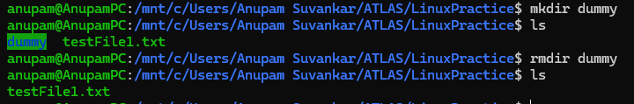

Task 5

https://lh7-rt.googleusercontent.com/docsz/AD_4nXdtl6Cs1QYIvZlrAh0Onhkz-QiXukpqTL0stwVIp113e0qUsiLRXhu8hP54DNfV4cYJagy58HWVdALgM4R067nOt-34MJZKRQmUXjLdlpbMODb0bJEqaR2nSLPsvDtrl6P7zT-_Dg?key=9CavezbwRAtplGQw_GT3qQ

Task 6

https://lh7-rt.googleusercontent.com/docsz/AD_4nXebsdYGJLEyB2SfIpoqXuSz7jL9-ZE4yw-1hYpWd8mhUI7b9nMIKaK0lU8iTOL-fQT9J9kGqIFQXkgle0aNYTuiYDA0JD8kBEiBO9KR12Sk3wFpD_QaAENyy6i4hUIBnY0-AOzr?key=9CavezbwRAtplGQw_GT3qQ

Task 7



Task 8

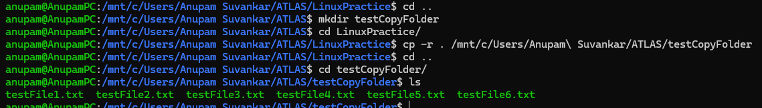

Task 9

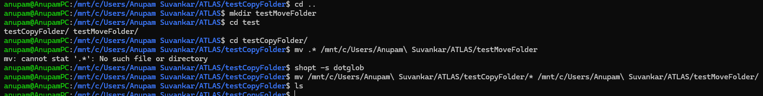

Task 10

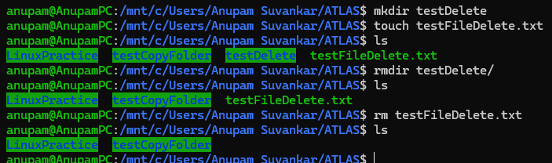

Task 11

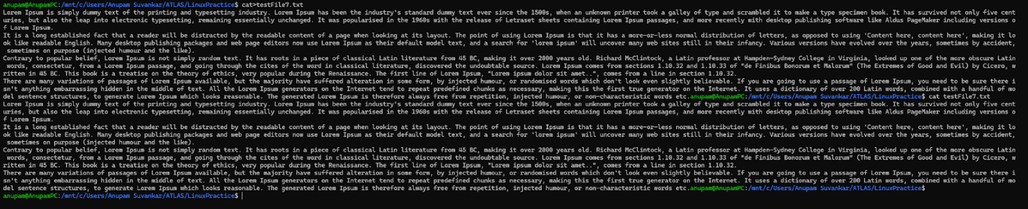

Task 12



Task 13



Task 14

https://lh7-rt.googleusercontent.com/docsz/AD_4nXdQxEv9xHOXLBcaILDDGaiE2WD6r8DBBV0yv8jSn01mvqKBkwitWSm6hQs3fzl6dZb8aq7AbV0SSO_GYHVhiZAeDWGW1WC0CIivJmHNq5zrjJV7chWC5kvef007XMEA6yWFpubE9g?key=9CavezbwRAtplGQw_GT3qQ

https://lh7-rt.googleusercontent.com/docsz/AD_4nXfa4YMgEkME6pKi_tuI5lxquojyK6PlpgLFgbaMblIEBmKRf09Js09b9hZRpYfBIwRJnmFhTBOCFgG9JV47QGgtzZOF-o-AdNa2TtVq_EBKCO9FwRyBa_qJ3twTiLG1scod26Ho?key=9CavezbwRAtplGQw_GT3qQ

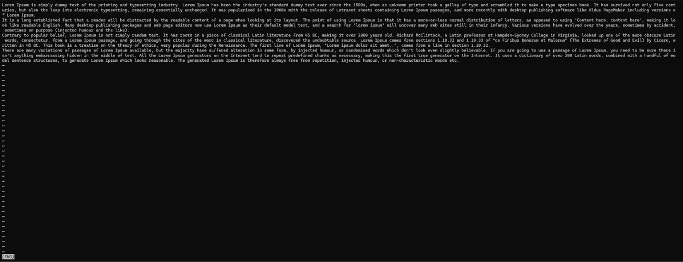

Task 15

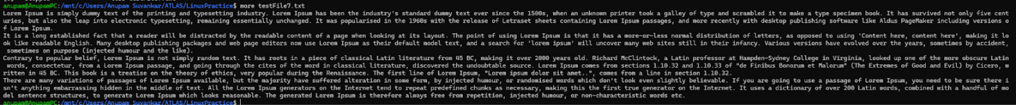

Task 16



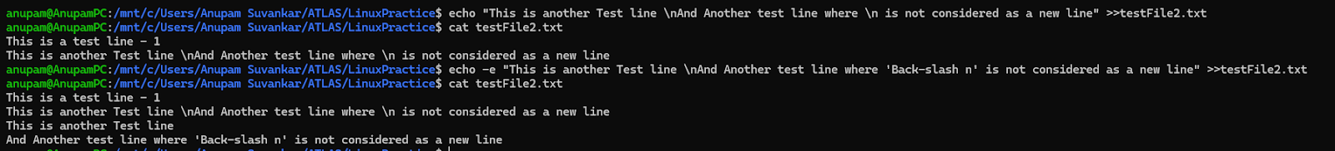

Task 17

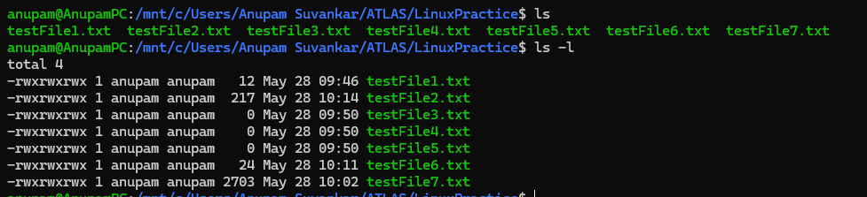

Task 18

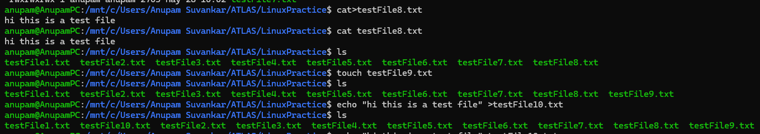

Task 19

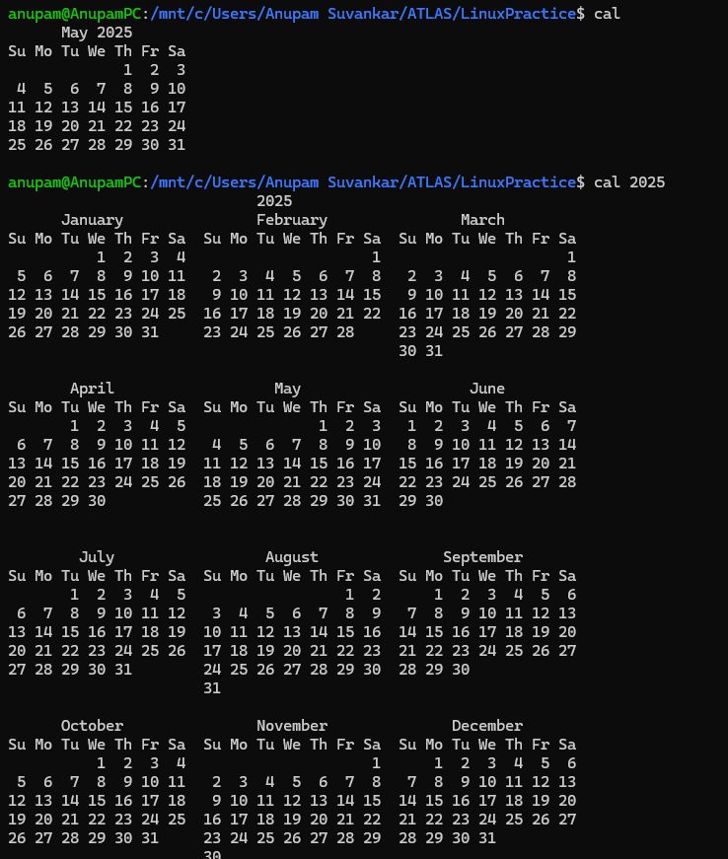

Task 20

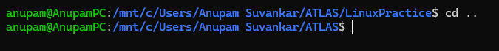

Task 21

https://lh7-rt.googleusercontent.com/docsz/AD_4nXf4IGXxCyMJ1MfmRINi2497l6BSXiTO0dRCTbaBKM65sIe_Mp0Ut88O_3uQA8oXpANOCxRJ-5TADnY_i1Bx0VXFhjQdAUsj0t2V_wgkhaRqjdXWU8CuYKss4VtmtbzCK3YSveqPuQ?key=9CavezbwRAtplGQw_GT3qQ

Task 22

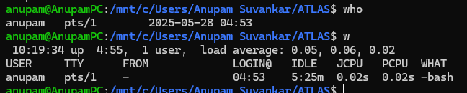

Task 23

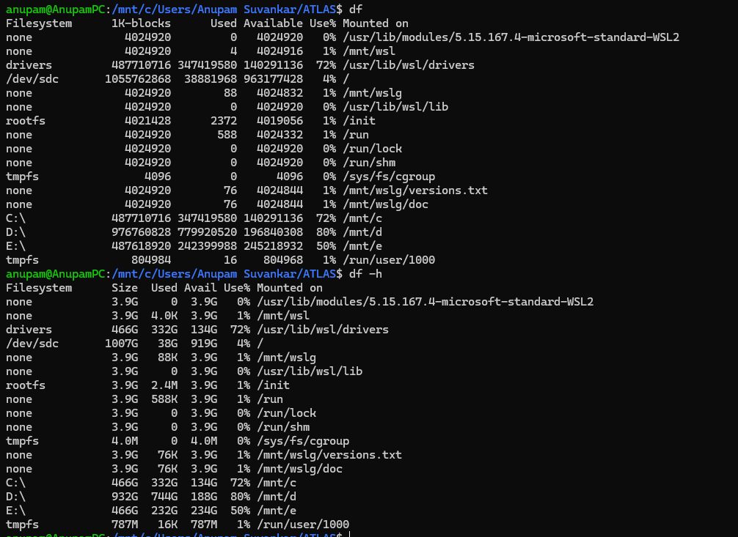

Task 24

Task 25  
https://lh7-rt.googleusercontent.com/docsz/AD_4nXf9wMSZ24Gi5f-OriEdmhpNXIwvMF2WY3GoL3lN3FkWVF__dNgHjspbX9FZls1z9IqiDsqTy3ta_-CsloWug7VptEznqSbcARPi4PzCBIYZfN0Vp5zBldIoRHar2YHoxU4Jh78N?key=9CavezbwRAtplGQw_GT3qQ

Task 26

https://lh7-rt.googleusercontent.com/docsz/AD_4nXewh8zKjkfl05kxRg70xWOgK2c1AzxioKqibEAacd9W4Rk4h12nwqqyMaZBV4sVFz57ogvk_BUTpfvVF-GWCiyXr1Z2zpiRIMaVTg9z8Z2sCqz2pIFPwsJr9L0eRFwbopOUDhwVJQ?key=9CavezbwRAtplGQw_GT3qQ

Task 27

. (single dot)

* Represents the current directory.
* You can use it when you want to refer to the directory you are currently in.

.. (double dot)

* Represents the parent directory (one level up).
* Used to move up one directory in the hierarchy.

Task 28

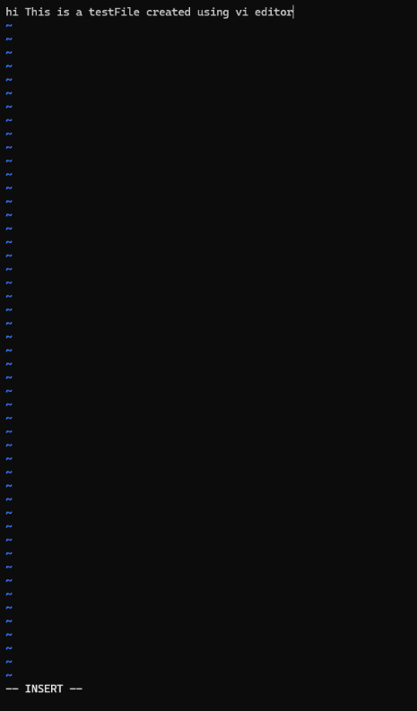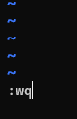

Task 29

https://lh7-rt.googleusercontent.com/docsz/AD_4nXfdoq_CDRdgirga6QxXIPYpwefcXIuexjRa8CXFWhd_ly1j7c1bE7NRNvZ8Pm-sUcFPpjGU2-ZCj7Cy6q4xOrNSFMCSlseS8Vcza7e3T489G8KUiHidiI7DRDzH9O1E8rnt2hasKA?key=9CavezbwRAtplGQw_GT3qQ

https://lh7-rt.googleusercontent.com/docsz/AD_4nXfo35tuS0kr-GdSBZAasT-s3xM3sl-DKp_ohdVX2K06XfMhKMScQzDmOO5VabqLTNXZvou6hLPT-D16KKd4x-m65o1Tsn2_fNpFXXGhcHS2tw21JWEuDLc9vJHjxA4U79oO0wLmzw?key=9CavezbwRAtplGQw_GT3qQ

Task 30

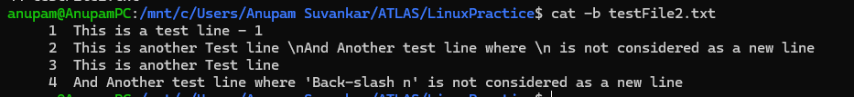

Task 31



Task 32

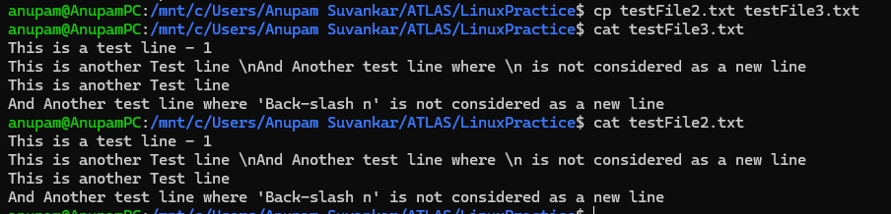

Task 33



Task 34



Task 35

https://lh7-rt.googleusercontent.com/docsz/AD_4nXfa_KVZIZIAiciY9gQFFaEXuk5jYmswbSwGy8CCFHYPpQyENDLDMHZCzahsJOA4sreYm_miA0h7aHoYbJP7P6OOvniCyFea-7UNpUYk0cHBvbbD6LRLTKIo3sh-Ki8gC3BOOEv5?key=9CavezbwRAtplGQw_GT3qQ